**Let's Get Started Coder!!**

**Fill the following Document**

**__________________________________________________________________________**

**1. Which one of the following is an Imperative Language??**

1. **HTML**
2. **CSS**
3. **Java Script**

**Answer:**

**Java Script**

**2. Which one of the following is a Declarative Language??**

1. **HTML**
2. **CSS**
3. **Java Script**

**Answer:**

**HTML**

**3. Name two uses of a DIV tag??**

**Answer:**

**The div tag is used in HTML to make divisions of content in the web page like (text, images, header, footer etc). Div tag has both open(<div>) and closing (</div>) tag and it is mandatory to close the tag.**

**4. What is the difference between relative positioning and absolute positioning in HTML?**

**Answer:**

**Position: relative Places an element relative to its current position without changing the layout around it.**

**Position: absolute Places an element relative to its parent’s position without changing the layout around it.**

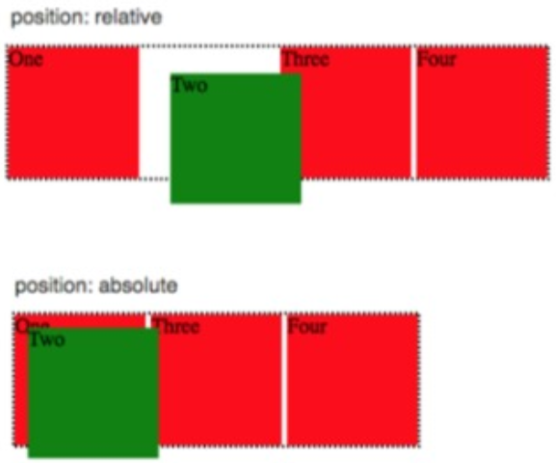

**5. What is the use of opacity in CSS??**

**Answer:**

**The opacity CSS property sets the opacity of an element. Opacity is the degree to which content behind an element is hidden, and is the opposite of transparency.**

**6. Which is the programming language used in the React Native Framework??**

**Answer:**

**JSX**

**7. Which online editor are we using for creating our apps in React Native Framework??**

**Answer:**

**Snack.expo**

**8. Write the steps to test your first designed app in the online editor on a mobile.**

**Answer:**

**We can test them by clicking web in which we can see on our laptop itself, there is a button named my device in that there will be a qr code in which we just need to scan through a camera and then we can see our code and last but not the least there are 2 buttons named IOS and Android in that we just need to click on tap play and then it will say u have to wait for 1-2 mins as some people are using this app.**

**9. What is the use of the render function in React Native Framework??**

**Answer:**

**The term “render prop” refers to a technique for sharing code between React components using a prop whose value is a function. A component with a render prop takes a function that returns a React element and calls it instead of implementing its own render logic.**

**10. What is the use of return function in React Native Framework??**

**Answer:**

**Whatever a function component returns is rendered as a React element. React elements let you describe what you want to see on the screen.**

**11. What are the various components in your first app that you designed??**

**Answer:**

**Components are like button, text, view, etc. which we use inside { } in import line**